Practical 14
Problem Definition
Develop an admin dashboard that displays user statistics, student count, event count and latest registrations. Restrict access to admin users only and show dynamic menu options based on role.
Code:-
Db.php:-

<?php
mysqli_report(MYSQLI_REPORT_ERROR | MYSQLI_REPORT_STRICT);

$conn = new mysqli("localhost", "root", "", "studenthub");
$conn->set_charset("utf8mb4");

echo "Connected database: ";
echo $conn->query("SELECT DATABASE()")->fetch_row()[0];

echo "<br>Users table columns:<br>";

$result = $conn->query("SHOW COLUMNS FROM users");

while ($row = $result->fetch_assoc()) {
echo htmlspecialchars($row["Field"]) . "<br>";
}
?>
Dashboard.php:-

<?php
session_start();

if (!isset($_SESSION["user_id"])) {
header("Location: login.php");
exit;
}

if (($_SESSION["role"] ?? "") === "admin") {
header("Location: admin.php");
exit;
}
?>

<!DOCTYPE html>
<html lang="en">
<head>
<meta charset="UTF-8">
<title>Student Dashboard</title>
<link rel="stylesheet" href="style.css">
</head>
<body>
<div class="content">
<h1>Student Dashboard</h1>

<p>
Welcome,
<?= htmlspecialchars($_SESSION["name"]) ?>!
</p>

<nav class="student-menu">
<a href="dashboard.php">Home</a>
<a href="admin.php">Admin Panel</a>
<a href="logout.php">Logout</a>
</nav>

<p>You are logged in as a student.</p>
</div>
</body>
</html>
Create_admin.php:-

<?php
require "db.php";

$name = "Admin";
$email = "admin@gmail.com";
$password = password_hash("Admin@123", PASSWORD_DEFAULT);
$role = "admin";

$stmt = $conn->prepare(
"INSERT INTO users (name, email, password, role)
VALUES (?, ?, ?, ?)"
);

$stmt->bind_param("ssss", $name, $email, $password, $role);

if ($stmt->execute()) {
echo "Admin created successfully!";
} else {
echo "Error: " . htmlspecialchars($stmt->error);
}
?>
Screenshot:-
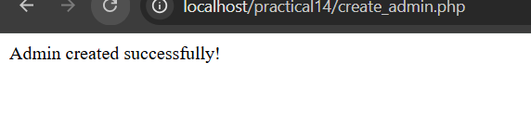
Admin.php:-

<?php
session_start();
require "db.php";

// Only admins can access this page
if (!isset($_SESSION["user_id"]) ||
($_SESSION["role"] ?? "") !== "admin") {
header("Location: login.php");
exit;
}

// Record dashboard access
$userId = (int) $_SESSION["user_id"];
$action = "Admin dashboard accessed";

$log = $conn->prepare(
"INSERT INTO audit_log (user_id, action) VALUES (?, ?)"
);
$log->bind_param("is", $userId, $action);
$log->execute();

// Get dashboard statistics
$totalUsers = $conn->query(
"SELECT COUNT(*) AS total FROM users"
)->fetch_assoc()["total"];

$totalStudents = $conn->query(
"SELECT COUNT(*) AS total FROM students"
)->fetch_assoc()["total"];

$totalEvents = $conn->query(
"SELECT COUNT(*) AS total FROM events"
)->fetch_assoc()["total"];

// Latest registrations
$latest = $conn->query(
"SELECT u.name, e.title, r.registered_at
FROM registrations r
JOIN users u ON r.user_id = u.id
JOIN events e ON r.event_id = e.id
ORDER BY r.registered_at DESC
LIMIT 5"
);

// Recent audit log
$audit = $conn->query(
"SELECT a.action, a.created_at, u.name
FROM audit_log a
LEFT JOIN users u ON a.user_id = u.id
ORDER BY a.id DESC
LIMIT 10"
);
?>

<!DOCTYPE html>
<html lang="en">
<head>
<meta charset="UTF-8">
<meta name="viewport" content="width=device-width, initial-scale=1.0">
<title>StudentHub Admin Dashboard</title>
<link rel="stylesheet" href="style.css">
</head>
<body>

<header class="topbar">
<h2>StudentHub Admin Panel</h2>
<span>
Welcome, <?= htmlspecialchars($_SESSION["name"]) ?>
</span>
<a class="logout" href="logout.php">Logout</a>
</header>

<div class="layout">
<nav class="sidebar">
<h3>Menu</h3>
<a href="admin.php">Dashboard</a>
<a href="admin.php#registrations">Latest Registrations</a>
<a href="admin.php#audit">Audit Log</a>
<a href="dashboard.php">Student Dashboard</a>
<a href="logout.php">Logout</a>
</nav>

<main class="content">
<h1>Admin Dashboard</h1>
<p>Manage and monitor StudentHub.</p>

<div class="stats">
<div class="stat-card">
<h3>Total Users</h3>
<p><?= $totalUsers ?></p>
</div>

<div class="stat-card">
<h3>Total Students</h3>
<p><?= $totalStudents ?></p>
</div>

<div class="stat-card">
<h3>Total Events</h3>
<p><?= $totalEvents ?></p>
</div>
</div>

<section id="registrations" class="panel">
<h2>Latest Registrations</h2>
<table>
<thead>
<tr>
<th>User</th>
<th>Event</th>
<th>Date</th>
</tr>
</thead>
<tbody>
<?php if ($latest && $latest->num_rows > 0): ?>
<?php while ($row = $latest->fetch_assoc()): ?>
<tr>
<td><?= htmlspecialchars($row["name"]) ?></td>
<td><?= htmlspecialchars($row["title"]) ?></td>
<td><?= htmlspecialchars($row["registered_at"]) ?></td>
</tr>
<?php endwhile; ?>
<?php else: ?>
<tr>
<td colspan="3">No registrations found.</td>
</tr>
<?php endif; ?>
</tbody>
</table>
</section>

<section id="audit" class="panel">
<h2>Audit Log</h2>
<table>
<thead>
<tr>
<th>User</th>
<th>Action</th>
<th>Date and Time</th>
</tr>
</thead>
<tbody>
<?php if ($audit && $audit->num_rows > 0): ?>
<?php while ($row = $audit->fetch_assoc()): ?>
<tr>
<td>
<?= htmlspecialchars($row["name"] ?? "Unknown") ?>
</td>
<td><?= htmlspecialchars($row["action"]) ?></td>
<td><?= htmlspecialchars($row["created_at"]) ?></td>
</tr>
<?php endwhile; ?>
<?php else: ?>
<tr>
<td colspan="3">No audit records found.</td>
</tr>
<?php endif; ?>
</tbody>
</table>
</section>
</main>
</div>

</body>
</html>
Login.php:-

<?php
session_start();
require "db.php";

$error = "";

if ($_SERVER["REQUEST_METHOD"] === "POST") {
$email = trim($_POST["email"] ?? "");
$password = $_POST["password"] ?? "";

// Use the actual database column names
$stmt = $conn->prepare(
"SELECT user_id, name, email, password_hash, role
FROM users
WHERE email = ?"
);

$stmt->bind_param("s", $email);
$stmt->execute();

$user = $stmt->get_result()->fetch_assoc();
$stmt->close();

// Verify the hashed password
if ($user && password_verify($password, $user["password_hash"])) {

session_regenerate_id(true);

$_SESSION["user_id"] = $user["user_id"];
$_SESSION["name"] = $user["name"];
$_SESSION["role"] = $user["role"];

// Save login action in the audit log
$userId = (int)$user["user_id"];
$action = "User logged in";

$log = $conn->prepare(
"INSERT INTO audit_log (user_id, action)
VALUES (?, ?)"
);
$log->bind_param("is", $userId, $action);
$log->execute();
$log->close();

// Redirect according to the user's role
if ($user["role"] === "admin") {
header("Location: admin.php");
} else {
header("Location: dashboard.php");
}
exit;

} else {
$error = "Invalid email or password.";
}
}
?>

<!DOCTYPE html>
<html lang="en">
<head>
<meta charset="UTF-8">
<meta name="viewport" content="width=device-width, initial-scale=1.0">
<title>StudentHub Login</title>
<link rel="stylesheet" href="style.css">
</head>
<body>

<div class="login-box">
<h2>StudentHub Login</h2>

<?php if ($error !== ""): ?>
<p class="error">
<?= htmlspecialchars($error) ?>
</p>
<?php endif; ?>

<form method="POST" action="">
<input type="email" name="email"
placeholder="Enter email" required>

<input type="password" name="password"
placeholder="Enter password" required>

<button type="submit">Login</button>
</form>
</div>

</body>
</html>
Screenshot:-
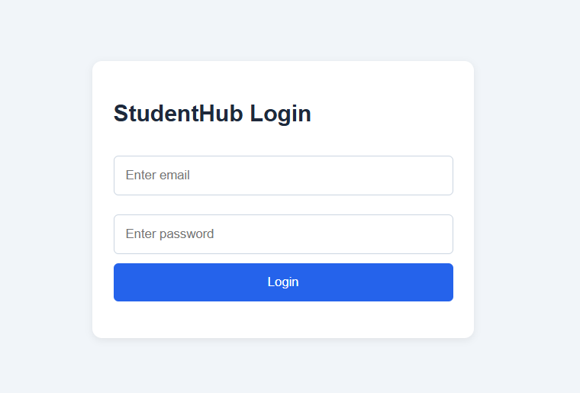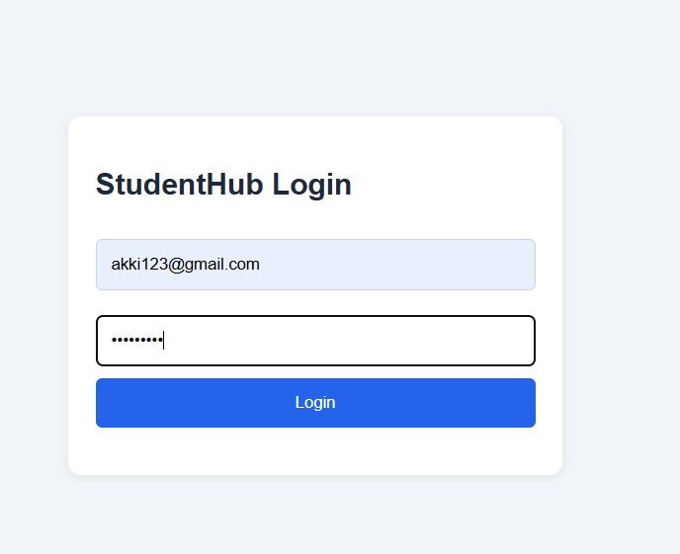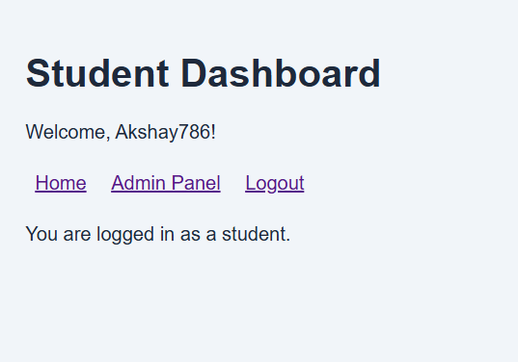
Logout.php:-

<?php
session_start();
require "db.php";

if (isset($_SESSION["user_id"])) {
$userId = (int) $_SESSION["user_id"];
$action = "User logged out";

$stmt = $conn->prepare(
"INSERT INTO audit_log (user_id, action) VALUES (?, ?)"
);
$stmt->bind_param("is", $userId, $action);
$stmt->execute();
}

$_SESSION = [];
session_destroy();

header("Location: login.php");
exit;
?>
Style.css:-

* {
box-sizing: border-box;
}

body {
margin: 0;
font-family: Arial, sans-serif;
background: #f1f5f9;
color: #1e293b;
}

.topbar {
background: #1e3a8a;
color: white;
padding: 18px 25px;
display: flex;
justify-content: space-between;
align-items: center;
flex-wrap: wrap;
gap: 12px;
}

.topbar h2 {
margin: 0;
}

.logout {
color: white;
background: #dc2626;
padding: 9px 14px;
border-radius: 5px;
text-decoration: none;
}

.layout {
display: flex;
min-height: calc(100vh - 70px);
}

.sidebar {
background: #0f172a;
width: 220px;
padding: 20px;
flex-shrink: 0;
}

.sidebar h3 {
color: white;
}

.sidebar a {
display: block;
color: #e2e8f0;
text-decoration: none;
padding: 12px 8px;
border-radius: 5px;
}

.sidebar a:hover {
background: #334155;
}

.content {
padding: 25px;
flex: 1;
min-width: 0;
}

.stats {
display: grid;
grid-template-columns: repeat(3, minmax(0, 1fr));
gap: 20px;
margin: 25px 0;
}

.stat-card, .panel, .login-box {
background: white;
padding: 22px;
border-radius: 10px;
box-shadow: 0 2px 8px #00000012;
}

.stat-card h3 {
color: #475569;
}

.stat-card p {
color: #2563eb;
font-size: 32px;
font-weight: bold;
margin-bottom: 0;
}

.panel {
margin-bottom: 25px;
overflow-x: auto;
}

table {
border-collapse: collapse;
width: 100%;
min-width: 450px;
}

th, td {
text-align: left;
border-bottom: 1px solid #e2e8f0;
padding: 12px;
}

th {
background: #eff6ff;
}

.login-box {
width: min(400px, 92%);
margin: 100px auto;
}

input {
width: 100%;
padding: 12px;
margin: 10px 0;
border: 1px solid #cbd5e1;
border-radius: 5px;
}

button {
width: 100%;
padding: 12px;
border: none;
background: #2563eb;
color: white;
border-radius: 5px;
cursor: pointer;
}

.error {
color: #dc2626;
}

.student-menu a {
display: inline-block;
margin: 8px;
}

@media (max-width: 700px) {
.layout {
flex-direction: column;
}

.sidebar {
width: 100%;
}

.stats {
grid-template-columns: 1fr;
}

.content {
padding: 15px;
}
}
Key Questions / Analysis / Interpretation
1. Are dashboard values loaded dynamically from the database?
Yes. Dashboard values such as total users, student count, event count, and latest registrations are fetched dynamically from the MySQL database using PHP queries. The values change when the database records are added, updated, or deleted.
2. Is access restricted to admin users?
Yes. Access is restricted using PHP sessions and role-based authentication. Only users with the admin role can access the admin dashboard. Unauthorized users are redirected to the login page or shown an access-denied message.
3. Are role-based menus working?
Yes. The dashboard displays menu options according to the logged-in user's role. Admin users can access administrative features, while student users can access only student-related features. This improves security and usability.
4. Are important admin actions recorded in audit_logs?
Yes. Important administrative actions, such as adding, updating, or deleting student records and managing events, can be recorded in the audit_logs table. The log stores details such as the admin's ID, action performed, timestamp, and relevant information for tracking and accountability.

